# EXPERIMENT 1

# Output:

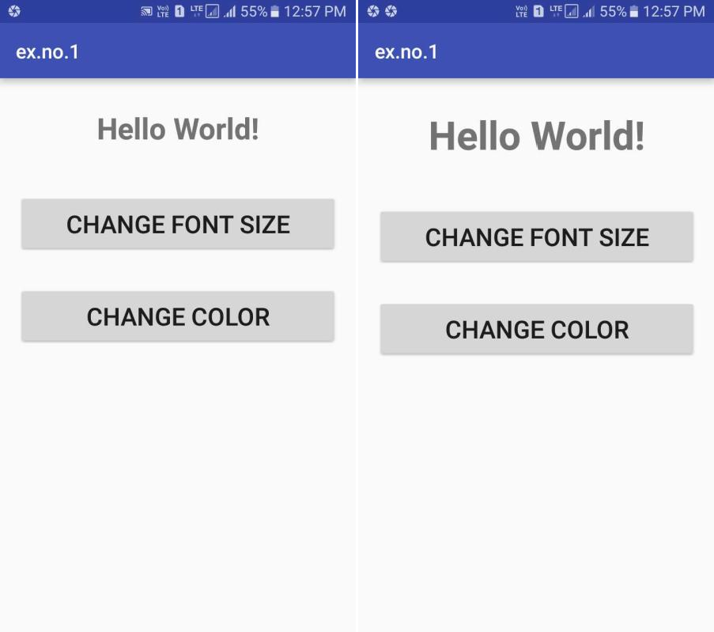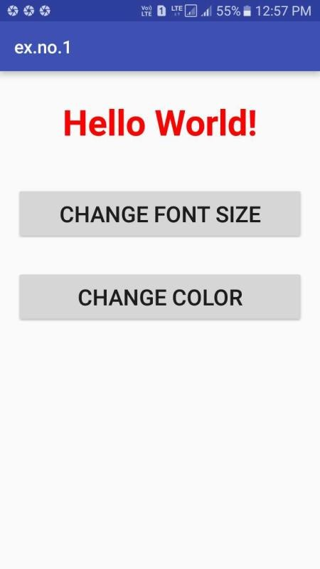

EXPERIMENT 2

# Output:

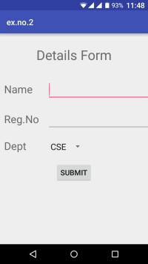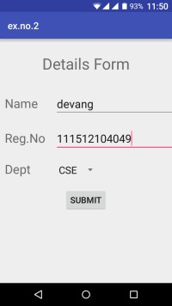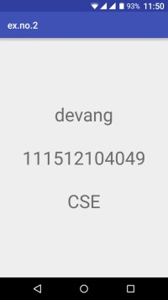

EXPERIMENT 3

# H:\APK\Screenshot_2018-12-21_130326.jpgOutput:

EXPERIMENT 4

# Output:

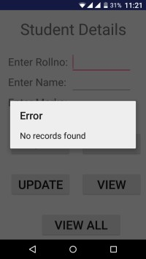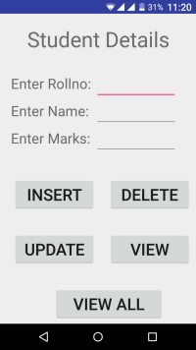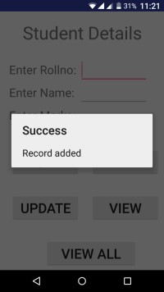

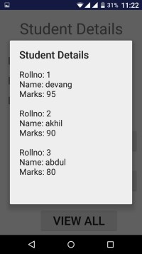 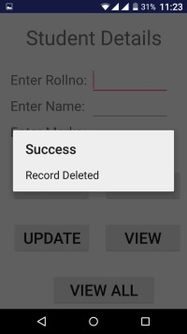 

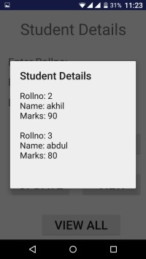

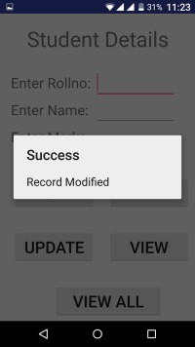 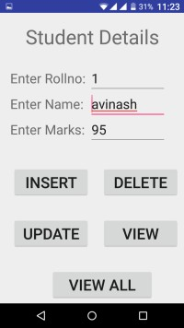

EXPERIMENT 5

# C:\Users\Admin\Desktop\5.pngC:\Users\Admin\Desktop\5.1.pngOutput:

EXPERIMENT 6

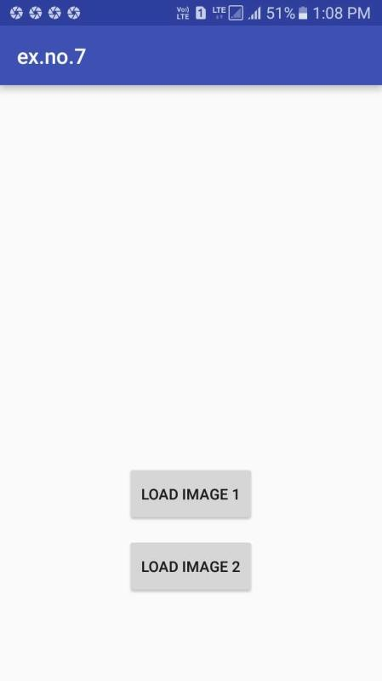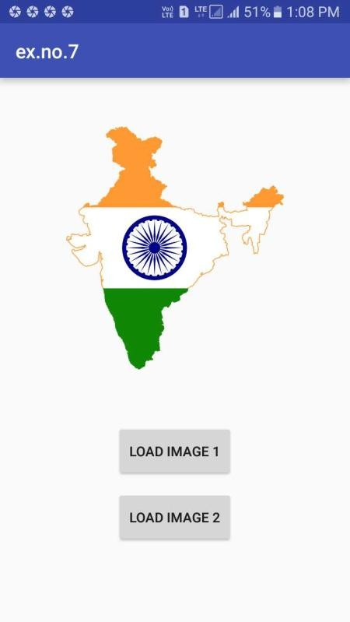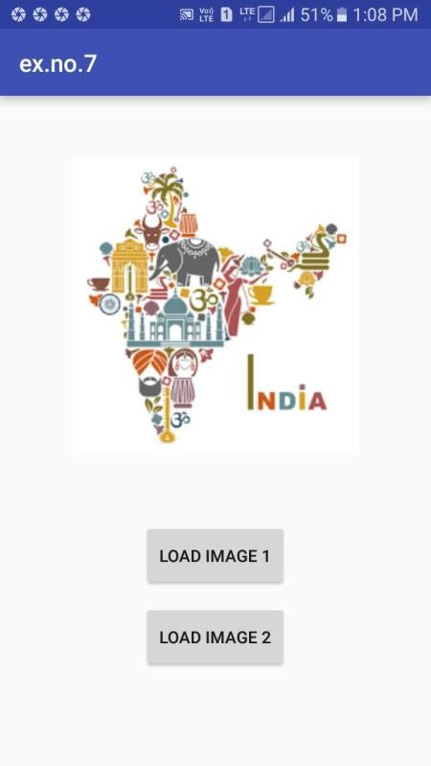

EXPERIMENT 7

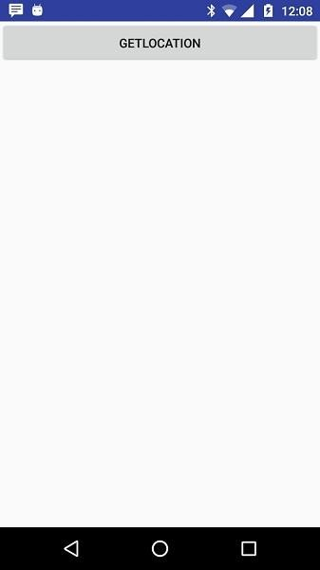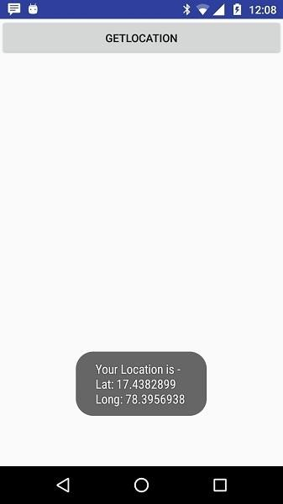

EXPERIMENT 8

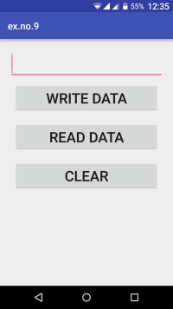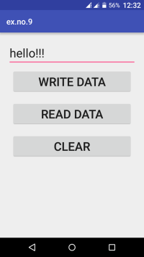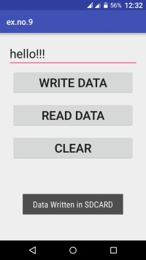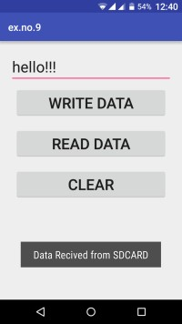

EXPERIMENT 9

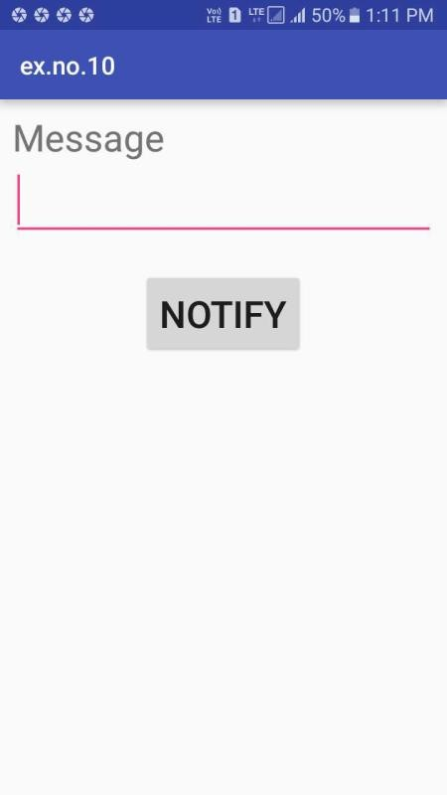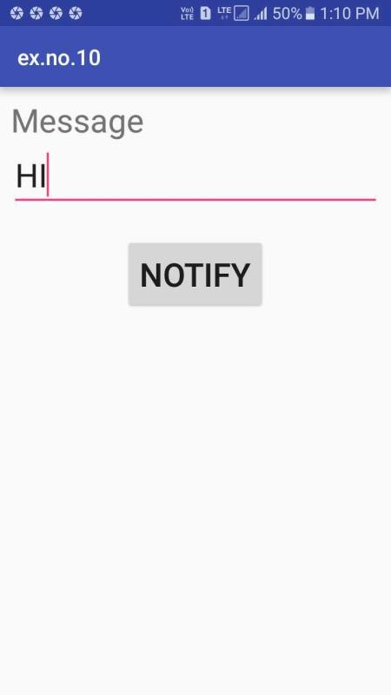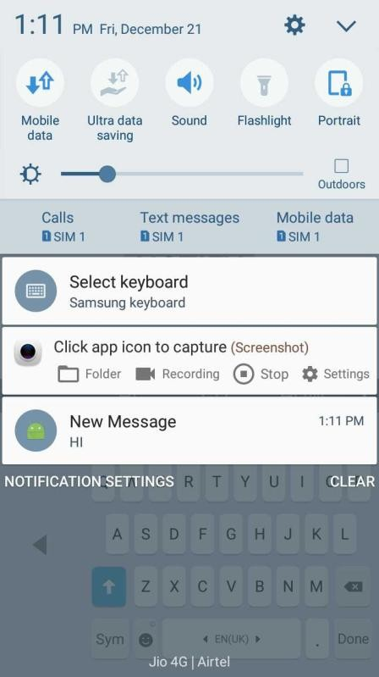

EXPERIMENT 10

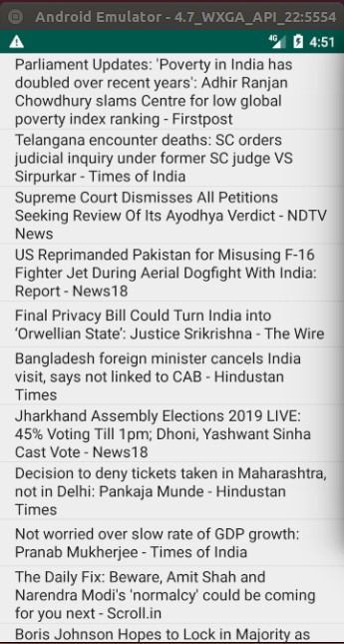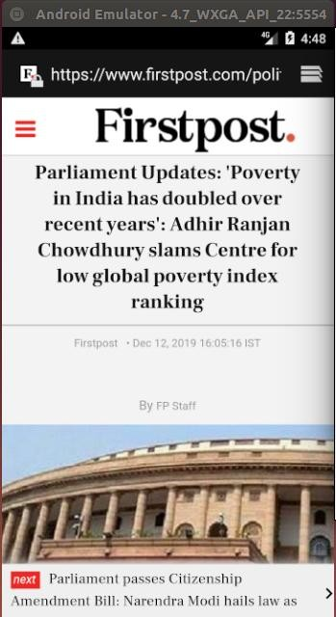

EXPERIMENT 11

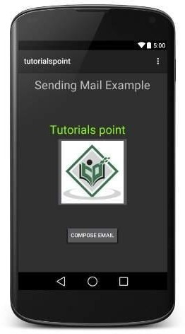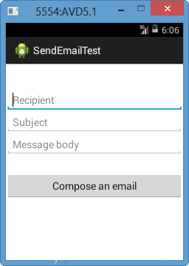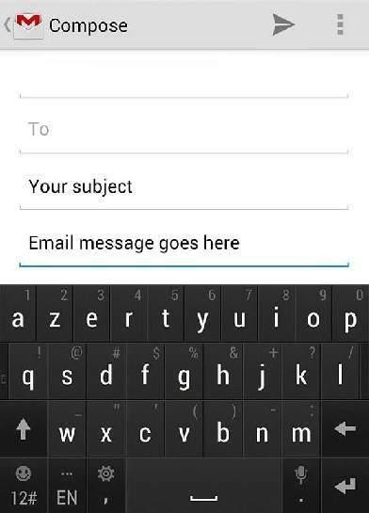

EXPERIMENT 12

# Graphical user interface, application Description automatically generatedI:\2019 - 2020\Even Sem\CS8662 - MAD Lab\MAD Lab Output\12.1.pngI:\2019 - 2020\Even Sem\CS8662 - MAD Lab\MAD Lab Output\12.2.pngI:\2019 - 2020\Even Sem\CS8662 - MAD Lab\MAD Lab Output\12.3.pngI:\2019 - 2020\Even Sem\CS8662 - MAD Lab\MAD Lab Output\12.4.pngI:\2019 - 2020\Even Sem\CS8662 - MAD Lab\MAD Lab Output\12.5.pngOutput: